RFID BASED AIRPORT LUGGAGE SECURITY SCANNING SYSTEM

Contents
Abstract

List of figures:

Fig1.Block diagram of project

Fig2.Pin diagram of AT89S52

Fig4.Block diagram of microcontroller AT89S52

Fig5.Oscillator connector

Fig6.External clock drive configuration

Fig7.Programming the flash

Fig8.Verifying the flash

Fig9.Architecture for serial communication

Fig10.Converter using MAX232

Fig11.LED interfacing with controller

Fig12.Pindiagram of MAX232 IC

Fig13.Block diagram of a power supply

Fig14.Stages of DC motor

Fig15.Block diagram of H bridge driver

Fig16.Circuit Symbol of Relay
Fig17.Relay operation and use of Protection diodes

List of Tables:

Table1.Port3 Alternate functions

Table2.Flash Programming modes

Table3.Pin configuration of LCD

Table4.Rated parameters of H bridge driver circuit

- Introduction
    - Introduction to RFID
    - Introduction to Embedded Systems
- Literature Survey
    - Present Existing System
    - Proposed System
    - Advantages of RFID
- Design and Implementation
    - Block Diagram
    - Microcontroller
    - Features of AT89S52
    - Pin description
    - Machine cycle for the 8052
    - Programming the Flash
    - Programming Interface
    - RS232 Cable
    - MAX232
    - Serial and LED interfacing with Microcontroller
    - LED interfacing
    - LCD
    - Serial Communication
    - SCON Register
    - Power Supply
    - DC Motor
- Result
    - Output Result
    - Programming code
- Conclusion
    - Future Scope
References

ABSTRACT

RFID is an acronym for Radio Frequency Identification. RFID is one member in the family of Automatic Identification and Data Capture (AIDC) technologies and is a fast and reliable means of identifying just about any material object. This project can be used for security purpose where it gives information about the authorized persons and unauthorized persons. This can be applied in real time systems as such in recording the attendance, in the companies and in industries to know who are authorized. RFID is increasingly used with biometric technologies for security. Primarily, the two main components involved in a Radio Frequency Identification system are the Transponder (tags that are attached to the object) and the Interrogator (RFID reader). Communication between the RFID reader and tags occurs wirelessly and generally doesn’t require a line of sight between the devices.

RFID tags are categorized as either active or passive. Active RFID tags are powered by an internal battery and are typically read/write, i.e., tag data can be rewritten and/or modified. An active tag's memory size varies according to application requirements; some systems operate with up to 1MB of memory. Passive RFID tags operate without a separate external power source and obtain operating power generated from the reader. This project uses passive tags. Read-only tags are typically passive and are programmed with a unique set of data (usually 32 to 128 bits) that cannot be modified. The reader has three main functions: energizing, demodulating and decoding. The antenna emits radio signals to activate the tag and to read and write data to it.

In this project, the RFID module reader typically contains a module (transmitter and receiver), a control unit and a coupling element (antenna). This module is interfaced with the micro controller and when the card is brought near to the RFID module it reads the data in the card and displays on the LCD. If the data in the card is matched with the data in the program memory then it compares and displays authorized message. If the data is not matched it displays unauthorized. For authorized message, the door gets opened and the person gets in after sometime the door gets closed. If it is an unauthorized person it alerts the persons through a buzzer. The RFID module indicates a buzzer whenever it reads the data from the RFID card.

The significant advantage of all types of RFID systems is the non contact, non-line-of-sight nature of the technology. Tags can be read through a variety of substances such as snow, fog, ice, paint, crusted grime, and other visually and environmentally challenging conditions, where barcodes or other optically read technologies would be useless. This project can provide security for the industries, companies, etc. This project uses regulated 5v, 500mA power supply. 7805, a three terminal voltage regulator is used for voltage regulation. Bridge type full wave rectifier is used to rectify the ac output of secondary of 230/12v step down transformer. The RFID module requires a separate +5v power supply.

1.INTRODUCTION

An embedded system is a combination of software and hardware to perform a dedicated task. Some of the main devices used in embedded products are Microprocessors and Microcontrollers.

Microprocessors are commonly referred to as general purpose processors as they simply accept the inputs, process it and give the output. In contrast, a microcontroller not only accepts the data as inputs but also manipulates it, interfaces the data with various devices, controls the data and thus finally gives the result.

1.1. Introduction to RFID

Radio-frequency identification (RFID) is an automatic detection method, relying on storing and remotely retrieving data using devices called RFID tags or transponders. The technology requires some extent of cooperation of an RFID reader and an RFID tag.

An RFID tag is an object that can be applied to or incorporated into a product, animal, or person for the purpose of identification and tracking using radio waves. Some tags can be read from several meters away and beyond the line of sight of the reader.

Most RFID tags contain at least two parts. One is an integrated circuit for storing and processing information, modulating and demodulating a radio frequency (RF) signal, and other specialized functions. The second is an antenna for receiving and transmitting the signal.

There are generally two types of RFID tags: active RFID tags, which contain a battery, and passive RFID tags, which have no battery.This project uses passive tags. Read-only tags are typically passive and are programmed with a unique set of data (usually 32 to 128 bits) that cannot be modified.

Future chip less RFID allows for discrete identification of tags without an integrated circuit, thereby allowing tags to be printed directly onto assets at a lower cost than traditional tags. Currently (2008) none of the chip less concepts has become operational.

Today, RFID is used in enterprise supply chain management to improve the efficiency of inventory tracking and management

Applications of RFID:

1. Access Control System

2. Attendance Recording System

3. Bank Locker System

4. Vehicle Parking System

5. Parts Identification

6. Person Identification

7. Airport Luggage

Of all this, we have implemented the RFID based Airport Luggage System.

1.2.Introduction to Embedded System

An embedded system can be defined as a computing device that does a specific focused job. Appliances such as the air-conditioner, VCD player, DVD player, printer, fax machine, mobile phone etc. are examples of embedded systems. Each of these appliances will have a processor and special hardware to meet the specific requirement of the application along with the embedded software that is executed by the processor for meeting that specific requirement. The embedded software is also called “firm ware”. The desktop/laptop computer is a general purpose computer. You can use it for a variety of applications such as playing games, word processing, accounting, software development and so on. In contrast, the software in the embedded systems is always fixed listed below:

· Embedded systems do a very specific task, they cannot be programmed to do different things. . Embedded systems have very limited resources, particularly the memory. Generally, they do not have secondary storage devices such as the CDROM or the floppy disk. Embedded systems have to work against some deadlines. A specific job has to be completed within a specific time. In some embedded systems, called real-time systems, the deadlines are stringent. Missing a deadline may cause a catastrophe-loss of life or damage to property. Embedded systems are constrained for power. As many embedded systems operate through a battery, the power consumption has to be very low.

· Some embedded systems have to operate in extreme environmental conditions such as very high temperatures and humidity.

Application Areas

Nearly 99 per cent of the processors manufactured end up in embedded systems. The embedded system market is one of the highest growth areas as these systems are used in very market segment- consumer electronics, office automation, industrial automation, biomedical engineering, wireless communication,

data communication, telecommunications, transportation, military and so on.

Consumer appliances

At home we use a number of embedded systems which include digital camera, digital diary, DVD player, electronic toys, microwave oven, remote controls for TV and air-conditioner, VCO player, video game consoles, video recorders etc. Today’s high-tech car has about 20 embedded systems for transmission control, engine spark control, air-conditioning, navigation etc. Even wristwatches are now

Becoming embedded systems. The palmtops are powerful embedded systems using which we can carry out many general-purpose tasks such as playing games and word processing.

Office automation

The office automation products using em embedded systems are copying machine, fax machine, key telephone, modem, printer, scanner etc.

Industrial automation

Today a lot of industries use embedded systems for process control. These include pharmaceutical, cement, sugar, oil exploration, nuclear energy, electricity generation and transmission. The embedded systems for industrial use are designed to carry out specific tasks such as monitoring the temperature, pressure, humidity, voltage, current etc., and then take appropriate action based on the monitored levels to control other devices or to send information to a centralized monitoring station. In hazardous industrial environment, where human presence has to be avoided, robots are used, which are programmed to do specific jobs. The robots are now becoming very powerful and carry out many interesting and complicated tasks such as hardware assembly.

Medical electronics

Almost every medical equipment in the hospital is an embedded system. These equipments include diagnostic aids such as ECG, EEG, blood pressure measuring devices, X-ray scanners; equipment used in blood analysis, radiation, colonscopy, endoscopy etc. Developments in medical electronics have paved way for more accurate diagnosis of diseases.

Computer networking

Computer networking products such as bridges, routers, Integrated Services Digital Networks (ISDN), Asynchronous Transfer Mode (ATM), X.25 and frame relay switches are embedded systems which implement the necessary data communication protocols. For example, a router interconnects two networks. The two networks may be running different protocol stacks. The router’s function is to obtain the data packets from incoming pores, analyze the packets and send them towards the destination after doing necessary protocol conversion. Most networking equipments, other than the end systems (desktop computers) we use to access the networks, are embedded systems

.

Telecommunications:

In the field of telecommunications, the embedded systems can be categorized as subscriber terminals and network equipment. The subscriber terminals such as key telephones, ISDN phones, terminal adapters, web cameras are embedded systems. The network equipment includes multiplexers, multiple access systems, Packet Assemblers Dissemblers (PADs), sate11ite modems etc. IP phone, IP gateway, IP gatekeeper etc. are the latest embedded systems that provide very low-cost voice communication over the Internet.

Wireless technologies

Advances in mobile communications are paving way for many interesting applications using embedded systems. The mobile phone is one of the marvels of the last decade of the 20’h century. It is a very powerful embedded system that provides voice communication while we are on the move. The Personal Digital Assistants and the palmtops can now be used to access multimedia services over the Internet. Mobile communication infrastructure such as base station controllers, mobile switching centers are also powerful embedded systems.

Insemination

Testing and measurement are the fundamental requirements in all scientific and engineering activities. The measuring equipment we use in laboratories to measure parameters such as weight, temperature, pressure, humidity, voltage, current etc. are all embedded systems. Test equipment such as oscilloscope, spectrum analyzer, logic analyzer, protocol analyzer, radio communication test set etc. are embedded systems built around powerful processors. Thank to miniaturization, the test and measuring equipment are now becoming portable facilitating easy testing and measurement in the field by field-personnel.

Security

Security of persons and information has always been a major issue. We need to protect our homes and offices; and also the information we transmit and store. Developing embedded systems for security applications is one of the most lucrative businesses nowadays. Security devices at homes, offices, airports etc. for authentication and verification are embedded systems. Encryption devices are nearly 99 per cent of

the processors that are manufactured end up in~ embedded systems. Embedded systems find applications in . every industrial segment- consumer electronics, transportation, avionics, biomedical engineering, manufacturing, process control and industrial automation, data communication, telecommunication, defense, security etc. Used to encrypt the data/voice being transmitted on communication links such as telephone lines. Biometric systems using fingerprint and face recognition are now being extensively used for user authentication in banking applications as well as for access control in high security buildings.

Finance
Financial dealing through cash and cheques are now slowly paving way for transactions using smart cards and ATM (Automatic Teller Machine, also expanded as Any Time Money) machines. Smart card, of the size of a credit card, has a small micro-controller and memory; and it interacts with the smart card reader! ATM machine and acts as an electronic wallet. Smart card technology has the capability of ushering in a cashless society. Well, the list goes on. It is no exaggeration to say that eyes wherever you go, you can see, or at least feel, the work of an embedded system

2.LITERATURE SURVEY

2.1.Introduction for present existing security system:

Bag tags, also known as baggage tags, baggage checks or luggage tickets, have traditionally been used by bus, train and airline companies to route passenger luggage that is checked on to the final destination. The passenger stub is typically handed to the passenger or attached to the ticket envelope: a) to aid the passenger in identifying their bag among similar bags at the destination baggage; b) as proof—still requested at a few airports—that the passenger is not removing someone else's bag from the baggage reclaim hall; c) as a means for the passenger and carrier to identify and trace a specific bag that has gone astray and was not delivered at the destination. Current bag tags include a bar code using the Interleaved 2 of 5 zymology. These bag tags are printed using thermal or barcode printer on an adhesive thermal paper stock. This printed strip is then attached to the luggage at check in. This allows for automated sorting of the bags by bar code readers.

There are two ways that bar code baggage tags are read; hand held scanners and in-line arrays. In-line arrays are built into the baggage conveyor system and use a 360 degree array of lasers to read the bar code tags from multiple angles as baggage and the orientation of the bar code tag can shift as it goes through the conveyor belt system. One of the limitations of this system is that to read bar codes from the bottom of the belt laser arrays are placed below the gap between two sections of conveyor belt. Due to the frequent build-up of debris and dust on these lower arrays the rate of successful reads can be low. Frequently, the "read rate", the percent of bar code tags successful read by these arrays can be as low as 85%. This means that more than one out of ten bar code baggage tags are not successfully read and these bags are shunted off for manual reading resulting in extra labor and delay.

For flights departing from an international airport within the European Union, bag tags are issued with green edges. Passengers are eligible to take these bags through a separate "Blue Channel" at Customs.

Disadvantages of Bar code system:

They Cost Money. As we mentioned in our last blog post, Document Scanning and Imaging Trends, companies are continuing to invest in scanners if the expense can be justified. Barcode scanners typically start at around $50 and can cost up to a couple hundred dollars but in almost every case, the investment is worth it! Companies that don't have a lot of inventory to manage, may find it cheaper to not invest in barcode scanners and instead to employees manually enter information. However, having employees manually enter in information costs a lot of money in the long run. In the end, most companies find they simply cannot afford to not have barcode scanners because manual work is about 10x less efficient than work with barcode scanners.

They Can Breakdown. Just like your computers can breakdown at any given time, your employees can even get sick, barcode scanners can eventually breakdown. You know the old saying ... you get what you pay for? If you purchase a cheaper scanner that's not going to be at a high quality level, it will most likely have a higher risk of breaking down comparing to a high quality scanner. In the event your barcode scanner does breakdown, we offer support To ensure our products won't break down on your, Governor Business Solutions offer warrantees with all our barcode scanners.

2.2.PROPOSED SYSTEM:

Radio Frequency Identification, or RFID, is auto identification and data capture (AIDC) technology, which uses radio-frequency waves to wirelessly transfer data between an interrogator/reader and movable or stationary items to identify, categorize and track them. RFID tracking technology is used for automatically identifying, counting or tracking objects and/or people. Usually some type of identifying number is attached to the object of interest. Information about that object is stored and retrieved from a database.

RFID has many advantages over barcodes, but barcodes have become a standard in many industries for many worthwhile reasons. Depending on the application, either system will have its strengths and weaknesses. When it comes time for you to make a decision between either systems, keep the initial and recurring costs in mind, as well as the potential return on your investments. In years past, implementing a full-scale RFID system was cost prohibitive for small to mid-size companies, but today, the difference in the cost of a new barcode system versus an RFID system may be minimal in certain applications. Also, investing in an RFID system may pay for itself over time due to potential increases in efficiency and decreases in errors.

With an RFID system, you could see improvements in your business due to these advantages:

RFID doesn’t need line of sight.

An RFID tag is read/write.

A barcode can only be read, and the data can never be changed once it has been printed onto a label. RFID tags can be read, and the data on the tag can be rewritten or modified as needed.

RFID tags are durable and reusable.

Because barcodes are typically printed on paper labels or other unprotected surfaces, they are easily damaged and rendered unreadable. Depending on your application, you can find RFID tags specifically designed to work in harsh conditions. A durable hardcase protects these RFID tags from impacts, heat, moisture, and changing weather conditions. As we mentioned previously, since RFID tags are updatable, they can be reused, which will cut costs in your deployments.

Data is encrypted.

Barcodes are easily counterfeited, and the data itself is always readable. With RFID tags, your data is much more secure as the information has the ability to be encrypted. Also, it’s much more difficult to replicate RFID tags recognized in your system.

2.3.ADVANTAGES OF RFID
RFID has many advantages over barcodes, but barcodes have become a standard in many industries for many worthwhile reasons. Depending on the application, either system will have its strengths and weaknesses. When it comes time for you to make a decision between either system, keep the initial and recurring costs in mind, as well as the potential return on your investments. In years past, implementing a full-scale RFID system was cost prohibitive for small to mid-size companies, but today, the difference in the cost of a new barcode system versus an RFID system may be minimal in certain applications. Also, investing in an RFID system may pay for itself over time due to potential increases in efficiency and decreases in errors.
With an RFID system, you could see improvements in your business due to these advantages:

1. RFID doesn’t need line of sight.
For a barcode to be read, the scanner must be placed directly in front of each label, and both need to be oriented in a very specific position in order to work properly. RFID tags on the other hand, don’t need to be directly in sight of an RFID reader. Because RFID uses radio waves to communicate, RFID tags only need to be within the read range of the reader, which will vary depending on the equipment.

2. An RFID tag is read/write.
A barcode can only be read, and the data can never be changed once it has been printed onto a label. RFID tags can be read, and the data on the tag can be rewritten or modified as needed.

3. RFID tags are durable and reusable.
Because barcodes are typically printed on paper labels or other unprotected surfaces, they are easily damaged and rendered unreadable. Depending on your application, you can find RFID tags specifically designed to work in harsh conditions. A durable hardcase protects these RFID tags from impacts, heat, moisture, and changing weather conditions. As we mentioned previously, since RFID tags are updatable, they can be reused, which will cut costs in your deployments.

4. Data is encrypted.
Barcodes are easily counterfeited, and the data itself is always readable. With RFID tags, your data is much more secure as the information has the ability to be encrypted. Also, it’s much more difficult to replicate RFID tags recognized in your system.

5. RFID tags are capable of storing more data.
Standard barcodes are limited in the amount of information they are capable of representing. An RFID tag actually stores data in non-volatile memory and is capable of storing up to 8 kilobytes of data in certain tags.

6. Read rate is greatly increased.
Each barcode must be individually scanned in order to be entered into the system. RFID systems can read multiple tags at the same time, and do not need line of sight. Since RFID readers are capable of reading hundreds of tags at once, the increase in read rate saves you time that can be spent elsewhere.

7. RFID tags can be printed with a barcode.
If you have a barcoding system in place, but would like to make the switch to RFID, or perhaps you have need of both barcodes and RFID, you may find using RFID tags with printable paper labels to be quite advantageous.
Overall, RFID systems have many more features than simple barcoding systems, but both RFID and barcodes are good fits for certain applications. Each situation must be analyzed on its own in order to determine if RFID is the right call.

3.DESIGN AND IMPLEMENTATION

3.1 Block Diagram
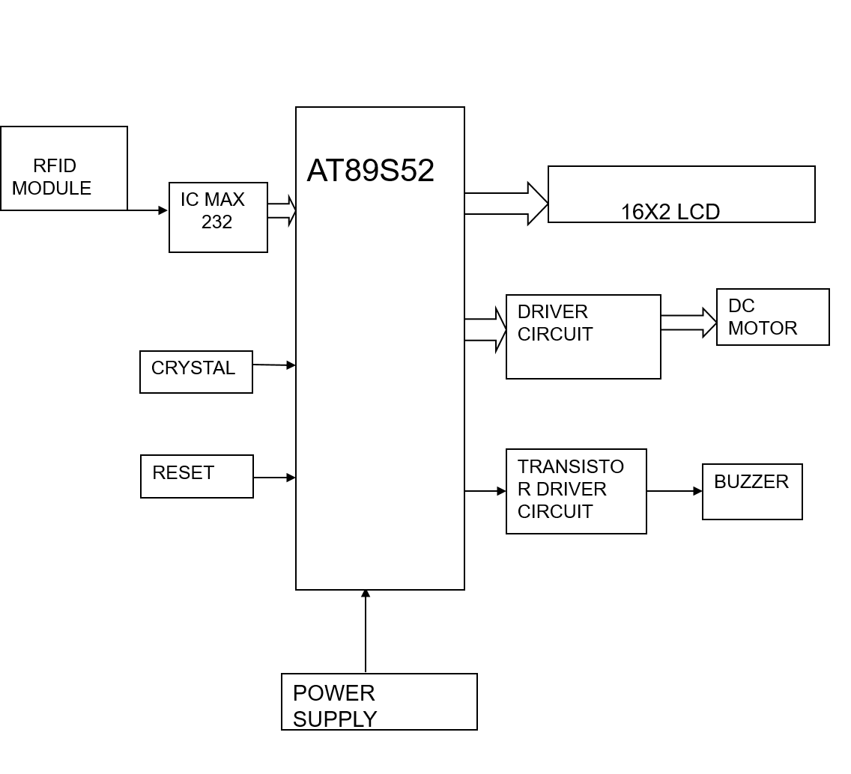

fig1:Block diagram of Project

Every embedded system consists of custom-built hardware built around a Central Processing Unit (CPU). This hardware also contains memory chips onto which the software is loaded. The software residing on the memory chip is also called the ‘firmware’. The embedded system architecture can be represented as a layered architecture as shown in Fig.

The operating system runs above the hardware, and the application software runs above the operating system. The same architecture is applicable to any computer including a desktop computer. However, there are significant differences. It is not compulsory to have an operating system in every embedded system. For small appliances such as remote control units, air conditioners, toys etc., there is no need for an operating system and you can write only the software specific to that application. For applications involving complex processing, it is advisable to have an operating system. In such a case, you need to integrate the application software with the operating system and then transfer the entire software on to the memory chip. Once the software is transferred to the memory chip, the software will continue to run for a long time you don’t need to reload new software.

Now, let us see the details of the various building blocks of the hardware of an embedded system. As shown in Fig. the building blocks are;

· Central Processing Unit (CPU)

· Memory (Read-only Memory and Random Access Memory)

· Input Devices

· Output devices

· Communication interfaces

· Application-specific circuitry
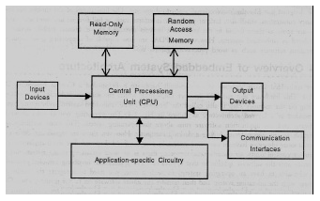

Central Processing Unit (CPU):

The Central Processing Unit (processor, in short) can be any of the following: microcontroller, microprocessor or Digital Signal Processor (DSP). A micro-controller is a low-cost processor. Its main attraction is that on the chip itself, there will be many other components such as memory, serial communication interface, analog-to digital converter etc. So, for small applications, a micro-controller is the best choice as the number of external components required will be very less. On the other hand, microprocessors are more powerful, but you need to use many external components with them. D5P is used mainly for applications in which signal processing is involved such as audio and video processing.

Memory:

The memory is categorized as Random Access 11emory (RAM) and Read Only Memory (ROM). The contents of the RAM will be erased if power is switched off to the chip, whereas ROM retains the contents even if the power is switched off. When power is switched on, the processor reads the ROM; the program is program is executed.

Input devices:

Unlike the desktops, the input devices to an embedded system have very limited capability. There will be no keyboard or a mouse, and hence interacting with the embedded system is no easy task. Many embedded systems will have a small keypad-you press one key to give a specific command. A keypad may be used to input only the digits. Many embedded systems used in process control do not have any input device for user interaction; they take inputs from sensors or transducers 1’fnd produce electrical signals that are in turn fed to other systems.

Output devices:

The output devices of the embedded systems also have very limited capability. Some embedded systems will have a few Light Emitting Diodes (LEDs) to indicate the health status of the system modules, or for visual indication of alarms. A small Liquid Crystal Display (LCD) may also be used to display some important parameters.

Communication interfaces:

The embedded systems may need to, interact with other embedded systems at they may have to transmit data to a desktop. To facilitate this, the embedded systems are provided with one or a few communication interfaces such as RS232, RS422, RS485, Universal Serial Bus (USB), IEEE 1394, Ethernet etc.

Application-specific circuitry:

Sensors, transducers, special processing and control circuitry may be required fat an embedded system, depending on its application. This circuitry interacts with the processor to carry out the necessary work. The entire hardware has to be given power supply either through the 230 volts main supply or through a battery. The hardware has to design in such a way that the power consumption is minimized.

3.2 MICROCONTROLLER

Microprocessors and microcontrollers are widely used in embedded systems products. Microcontroller is a programmable device. A microcontroller has a CPU in addition to a fixed amount of RAM, ROM, I/O ports and a timer embedded all on a single chip. The fixed amount of on-chip ROM, RAM and number of I/O ports in microcontrollers makes them ideal for many applications in which cost and space are critical.

The Intel 8052 is a Harvard architecture, single chip microcontroller (µC) which was developed by Intel in 1980 for use in embedded systems. It was popular in the 1980s and early 1990s, but today it has largely been superseded by a vast range of enhanced devices with 8052-compatible processor cores that are manufactured by more than 20 independent manufacturers including Atmel, Inferno Technologies and Maxim Integrated Products.

8052 is an 8-bit processor, meaning that the CPU can work on only 8 bits of data at a time. Data larger than 8 bits has to be broken into 8-bit pieces to be processed by the CPU. 8052 is available in different memory types such as UV-EPROM, Flash and NV-RAM.

The microcontroller used in this project is AT89S52. Atmel Corporation introduced this 89S52 microcontroller. This microcontroller belongs to 8052 family. This microcontroller had 128 bytes of RAM, 4K bytes of on-chip ROM, two timers, one serial port and four ports (each 8-bits wide) all on a single chip. AT89S52 is Flash type 8052.

The present project is implemented on Keil Uvision. In order to program the device, Proload tool has been used to burn the program onto the microcontroller.

The features, pin description of the microcontroller and the software tools used are discussed in the following sections.

Description:

The AT89S52 is a low-voltage, high-performance CMOS 8-bit microcomputer with 4K bytes of Flash programmable memory In addition, the AT89S52 is designed with static logic for operation down to zero frequency and supports two software selectable power saving modes. The Idle Mode stops the CPU while allowing the RAM, timer/counters, serial port and interrupt system to continue functioning. The power-down mode saves the RAM contents but freezes the oscillator disabling all other chip functions until the next hardware reset.
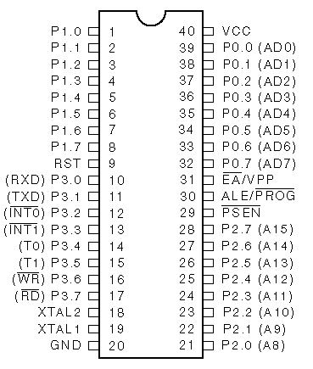

Fig2: Pin diagram of AT89S52

Fig3: Block diagram of Microcontroller AT89S52

3.2.1 FEATURES OF AT89S52:
- 4K Bytes of Re-programmable Flash Memory.
- RAM is 128 bytes.
- 2.7V to 6V Operating Range.
- Fully Static Operation: 0 Hz to 24 MHz.
- Two-level Program Memory Lock.
- 128 x 8-bit Internal RAM.
- 32 Programmable I/O Lines.
- Two 16-bit Timer/Counters.
- Six Interrupt Sources.
- Programmable Serial UART Channel.
- Low-power Idle and Power-down Modes.

3.2.2 PIN DESCRIPTION:

Vcc - Pin 40 provides supply voltage to the chip. The voltage source is +5V.

GND - Pin 20 is the ground.

XTAL1 and XTAL2

XTAL1 and XTAL2 are the input and output, respectively, of an inverting amplifier that can be configured for use as an on-chip oscillator, as shown in Figure 11. Either a quartz crystal or ceramic resonator may be used. To drive the device from an external clock source, XTAL2 should be left unconnected while XTAL1 is driven, as shown in the below figure. There are no requirements on the duty cycle of the external clock signal, since the input to the internal clocking circuitry is through a divide-by-two flip-flop, but minimum and maximum voltage high and low time specifications must be observed.

Fig4: Oscillator Connections

C1, C2 = 30 pF ± 10 pF for Crystals

= 40 pF ± 10 pF for Ceramic Resonators

Fig5: External Clock Drive Configuration

RESET

Pin9 is the reset pin. It is an input and is active high. Upon applying a high pulse to this pin, the microcontroller will reset and terminate all the activities. This is often referred to as a power-on reset.

EA (External access)

Pin 31 is EA. It is an active low signal. It is an input pin and must be connected to either Vcc or GND but it cannot be left unconnected.

The 8052 family members all come with on-chip ROM to store programs. In such cases, the EA pin is connected to Vcc. If the code is stored on an external ROM, the EA pin must be connected to GND to indicate that the code is stored externally.

PSEN (Program store enable)

This is an output pin.

ALE (Address latch enable)

This is an output pin and is active high.

Ports 0, 1, 2 and 3

The four ports P0, P1, P2 and P3 each use 8 pins, making them 8-bit ports. All the ports upon RESET are configured as input, since P0-P3 have value FFH on them.

Port 0(P0)

Port 0 is also designated as AD0-AD7, allowing it to be used for both address and data. ALE indicates if P0 has address or data. When ALE=0, it provides data D0-D7, but when ALE=1, it has address A0-A7. Therefore, ALE is used for demultiplexing address and data with the help of an internal latch.

When there is no external memory connection, the pins of P0 must be connected to a 10K-ohm pull-up resistor. This is due to the fact that P0 is an open drain. With external pull-up resistors connected to P0, it can be used as a simple I/O, just like P1 and P2. But the ports P1, P2 and P3 do not need any pull-up resistors since they already have pull-up resistors internally. Upon reset, ports P1, P2 and P3 are configured as input ports.

2.3 Port 1 and Port 2

With no external memory connection, both P1 and P2 are used as simple I/O. With external memory connections, port 2 must be used along with P0 to provide the 16-bit address for the external memory. Port 2 is designated as A8-A15 indicating its dual function. While P0 provides the lower 8 bits via A0-A7, it is the job of P2 to provide bits A8-A15 of the address.

2.4 Port 3

Port 3 occupies a total of 8 pins, pins 10 through 17. It can be used as input or output. P3 does not need any pull-up resistors, the same as port 1 and port 2. Port 3 has an additional function of providing some extremely important signals such as interrupts.

Table1: Port 3 Alternate Functions

Machine cycle for the 8052

The CPU takes a certain number of clock cycles to execute an instruction. In the 8052 family, these clock cycles are referred to as machine cycles. The length of the machine cycle depends on the frequency of the crystal oscillator. The crystal oscillator, along with on-chip circuitry, provides the clock source for the 8052 CPU.

The frequency can vary from 4 MHz to 30 MHz, depending upon the chip rating and manufacturer. But the exact frequency of 11.0592 MHz crystal oscillator is used to make the 8052 based system compatible with the serial port of the IBM PC.

In the original version of 8052, one machine cycle lasts 12 oscillator periods. Therefore, to calculate the machine cycle for the 8052, the calculation is made as 1/12 of the crystal frequency and its inverse is taken.

The assembly language program is written and this program has to be dumped into the microcontroller for the hardware kit to function according to the software. The program dumped in the microcontroller is stored in the Flash memory in the microcontroller. Before that, this Flash memory has to be programmed and is discussed in the next section.

3.2.4 Programming the Flash

The AT89S52 is normally shipped with the on-chip Flash memory array in the erased state (that is, contents = FFH) and ready to be programmed. The programming interface accepts either a high-voltage (12-volt) or a low-voltage (VCC) program enable signal. The low-voltage programming mode provides a convenient way to program the AT89S52 inside the user’s system, while the high-voltage programming mode is compatible with conventional third party Flash or EPROM programmers. The AT89S52 is shipped with either the high-voltage or low-voltage programming mode enabled. The respective top-side marking and device signature codes are listed in the following table.

The AT89S52 code memory array is programmed byte-byte in either programming mode. To program any nonblank byte in the on-chip Flash Memory, the entire memory must be erased using the Chip Erase Mode.

Programming Algorithm:

Before programming the AT89S52, the address, data and control signals should be set up according to the Flash programming mode table. To program the AT89S52, the following steps should be considered:

1. Input the desired memory location on the address lines.

2. Input the appropriate data byte on the data lines.

3. Activate the correct combination of control signals.

4. Raise EA/VPP to 12V for the high-voltage programming mode.

5. Pulse ALE/PROG once to program a byte in the Flash array or the lock bits. The byte-write cycle is self-timed and typically takes no more than 1.5 ms.

Repeat steps 1 through 5, changing the address and data for the entire array or until the end of the object file is reached.

Data Polling:

The AT89S52 features Data Polling to indicate the end of a write cycle. During a write cycle, an attempted read of the last byte written will result in the complement of the written datum on PO.7. Once the write cycle has been completed, true data are valid on all outputs, and the next cycle may begin. Data Polling may begin any time after a write cycle has been initiated.

Ready/Busy:

The progress of byte programming can also be monitored by the RDY/BSY output signal. P3.4 is pulled low after ALE goes high during programming to indicate BUSY. P3.4 is pulled high again when programming is done to indicate READY.

Chip Erase:

The entire Flash array is erased electrically by using the proper combination of control signals and by holding ALE/PROG low for 10 ms. The code array is written with all “1”s. The chip erase operation must be executed before the code memory can be re-programmed.

Reading the Signature Bytes:

The signature bytes are read by the same procedure as a normal verification of locations 030H, 031H, and 032H, except that P3.6 and P3.7 must be pulled to a logic low. The values returned are as follows.

(030H) = 1EH indicates manufactured by Atmel

(031H) = 51H indicates 89S52

(032H) = FFH indicates 12V programming

(032H) = 05H indicates 5V programming

3.2.5 Programming Interface:

Every code byte in the Flash array can be written and the entire array can be erased by using the appropriate combination of control signals. The write operation cycle is self timed and once initiated, will automatically time itself to completion. All major programming vendors offer worldwide support for the Atmel microcontroller series.

Table2: Flash Programming Modes

Fig6: Programming the Flash

Fig7: Verifying the Flash

Serial Communication

The main requirements for serial communication are:

1. Microcontroller

2. PC

3. RS 232 cable

4. MAX 232 IC

5. HyperTerminal

When the pins P3.0 and P3.1 of microcontroller are set, UART, which is inbuilt in the microcontroller, will be enabled to start the serial communication.

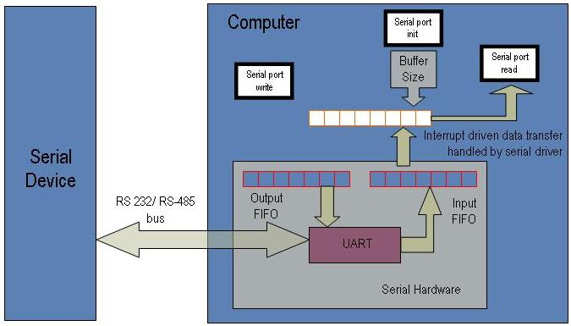

Fig8: Architecture for Serial Communication

Asynchronous and Synchronous Communication

Computers transfer data in two ways: parallel and serial. In parallel data transfers, often 8 or more lines are used to transfer data to a device that is only a few feet away. Although a lot of data can be transferred in a short amount of time by using many wires in parallel, the distance cannot be great.
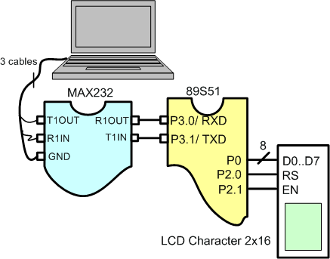

Fig9: communication using cables between pc to microcontroller

To transfer to a device located many meters away, the serial method is best suitable. In serial communication, the data is sent one bit at a time. The 8051 has serial communication capability built into it, thereby making possible fast data transfer using only a few wires.

The fact that serial communication uses a single data line instead of the 8-bit data line instead of the 8-bit data line of parallel communication not only makes it cheaper but also enables two computers located in two different cities to communicate over the telephone.

Serial data communication uses two methods, asynchronous and synchronous. The synchronous method transfers a block of data at a time, while the asynchronous method transfers a single byte at a time. With synchronous communications, the two devices initially synchronize themselves to each other, and then continually send characters to stay in sync. Even when data is not really being sent, a constant flow of bits allows each device to know where the other is at any given time. That is, each character that is sent is either actual data or an idle character. Synchronous communications allows faster data transfer rates than asynchronous methods, because additional bits to mark the beginning and end of each data byte are not required. The serial ports on IBM-style PCs are asynchronous devices and therefore only support asynchronous serial communications.

Asynchronous means "no synchronization", and thus does not require sending and receiving idle characters. However, the beginning and end of each byte of data must be identified by start and stop bits. The start bit indicates when the data byte is about to begin and the stop bit signals when it ends. The requirement to send these additional two bits causes asynchronous communication to be slightly slower than synchronous however it has the advantage that the processor does not have to deal with the additional idle characters.

There are special IC chips made by many manufacturers for serial data communications. These chips are commonly referred to as UART(universal asynchronous receiver-transmitter) and USART(universal synchronous-asynchronous receiver-transmitter). The 8051 has a built-in UART.

In the asynchronous method, the data such as ASCII characters are packed between a start and a stop bit. The start bit is always one bit, but the stop bit can be one or two bits. The start bit is always a 0 (low) and stop bit (s) is 1 (high). This is called framing.

The rate of data transfer in serial data communication is stated as bps (bits per second). Another widely used terminology for bps is baud rate. The data transfer rate of a given computer system depends on communication ports incorporated into that system. And in asynchronous serial data communication, this baud rate is generally limited to 100,000bps. The baud rate is fixed to 9600bps in order to interface with the microcontroller using a crystal of 11.0592 MHz.

3.2.5 RS232 CABLE:

To allow compatibility among data communication equipment, an interfacing standard called RS232 is used. Since the standard was set long before the advent of the TTL logic family, its input and output voltage levels are not TTL compatible. For this reason, to connect any RS232 to a microcontroller system, voltage converters such as MAX232 are used to convert the TTL logic levels to the RS232 voltage levels and vice versa.

3.2.6 MAX 232:

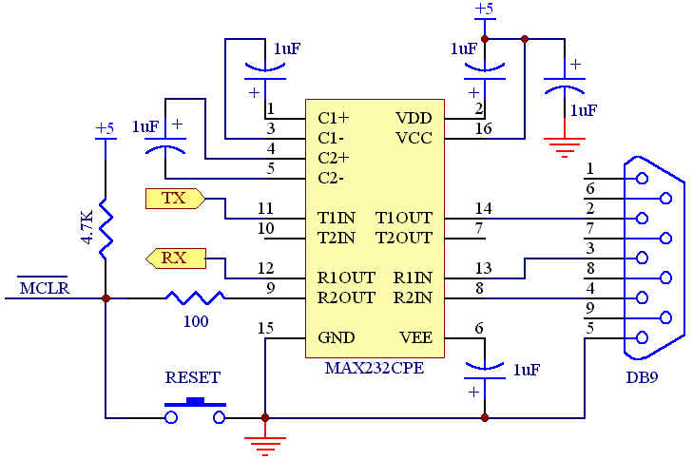
Max232 IC is a specialized circuit which makes standard voltages as required by RS232 standards. This IC provides best noise rejection and very reliable against discharges and short circuits. MAX232 IC chips are commonly referred to as line drivers.

Fig10:RS-232 Converter using MAX232

To ensure data transfer between PC and microcontroller, the baud rate and voltage levels of Microcontroller and PC should be the same. The voltage levels of microcontroller are logic1 and logic 0 i.e., logic 1 is +5V and logic 0 is 0V. But for PC, RS232 voltage levels are considered and they are: logic 1 is taken as -3V to -25V and logic 0 as +3V to +25V. So, in order to equal these voltage levels, MAX232 IC is used. Thus this IC converts RS232 voltage levels to microcontroller voltage levels and vice versa.

MAX 232 INTERFACING WITH MICROCONTROLLER:

TxD( P3.1)

RxD (P3.0)

MAX 232
11
11
100
12
ARM
14
13
2
3
5
DB-9

SWITCH AND LED INTERFACING WITH THE MICROCONTROLLER

Switches and LEDs are the most widely used input/output devices of the 8051.

SWITCH INTERFACING:

CPU accesses the switches through ports. Therefore these switches are connected to a microcontroller. This switch is connected between the supply and ground terminals. A single microcontroller (consisting of a microprocessor, RAM and EEPROM and several ports all on a single chip) takes care of hardware and software interfacing of the switch.

These switches are connected to an input port. When no switch is pressed, reading the input port will yield 1s since they are all connected to high (Vcc). But if any switch is pressed, one of the input port pins will have 0 since the switch pressed provides the path to ground. It is the function of the microcontroller to scan the switches continuously to detect and identify the switch pressed. The switches that we are using in our project are 4 leg micro switches of momentary type.

Thus now the two conditions are to be remembered:

1. When the switch is open, the total supply i.e., Vcc appears at the port pin P2.0

P2.0 = 1

When the switch is closed i.e., when it is pressed, the total supply path is provided to ground. Thus the voltage value at the port pin P2.0 will be zero.

P2.0 = 0

By reading the pin status, the microcontroller identifies whether the switch is pressed or not. When the switch is pressed, the corresponding related to this switch press written in the program will be executed.

3.2.7 LED INTERFACING:

LED stands for Light Emitting Diode.

Microcontroller port pins cannot drive these LEDs as these require high currents to switch on. Thus the positive terminal of LED is directly connected to Vcc, power supply and the negative terminal is connected to port pin through a current limiting resistor. This current limiting resistor is connected to protect the port pins from sudden flow of high currents from the power supply.

Thus in order to glow the LED, first there should be a current flow through the LED. In order to have a current flow, a voltage difference should exist between the LED terminals. To ensure the voltage difference between the terminals and as the positive terminal of LED is connected to power supply Vcc, the negative terminal has to be connected to ground. Thus this ground value is provided by the microcontroller port pin. This can be achieved by writing an instruction “CLR P1.0”. With this, the port pin P1.0 is initialized to zero and thus now a voltage difference is established between the LED terminals and accordingly, current flows and therefore the LED glows. LED and switches can be connected to any one of the four port pins.

Vcc

P1.0

Fig11: LED Interfacing with the microcontroller

3.2.8 LIQUID CRYSTAL DISPLAY:

LCD stands for Liquid Crystal Display. LCD is finding wide spread use replacing LEDs (seven segment LEDs or other multi segment LEDs) because of the following reasons:

1. The declining prices of LCDs.

2. The ability to display numbers, characters and graphics. This is in contrast to LEDs, which are limited to numbers and a few characters.

3. Incorporation of a refreshing controller into the LCD, thereby relieving the CPU of the task of refreshing the LCD. In contrast, the LED must be refreshed by the CPU to keep displaying the data.

4. Ease of programming for characters and graphics.

These components are “specialized” for being used with the microcontrollers, which means that they cannot be activated by standard IC circuits. They are used for writing different messages on a miniature LCD.

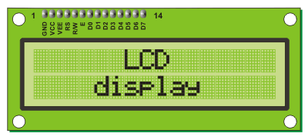
A model described here is for its low price and great possibilities most frequently used in practice. It is based on the HD44780 microcontroller (Hitachi) and can display messages in two lines with 16 characters each. It displays all the alphabets, Greek letters, punctuation marks, mathematical symbols etc. In addition, it is possible to display symbols that user makes up on its own. Automatic shifting message on display (shift left and right), appearance of the pointer, backlight etc. are considered as useful characteristics.

Pins Functions

There are pins along one side of the small printed board used for connection to the microcontroller. There are total of 14 pins marked with numbers (16 in case the background light is built in). Their function is described in the table below:

Function | Pin Number | Name | Logic State | Description
Ground | 1 | Vss | - | 0V
Power supply | 2 | Vdd | - | +5V
Contrast | 3 | Vee | - | 0 – Vdd
Control of operating | 4 | RS | 0  1 | D0 – D7 are interpreted as commands  D0 – D7 are interpreted as data
Control of operating | 5 | R/W | 0  1 | Write data (from controller to LCD)  Read data (from LCD to controller)
Control of operating | 6 | E | 0  1  From 1 to 0 | Access to LCD disabled  Normal operating  Data/commands are transferred to LCD
Data / commands | 7 | D0 | 0/1 | Bit 0 LSB
Data / commands | 8 | D1 | 0/1 | Bit 1
Data / commands | 9 | D2 | 0/1 | Bit 2
Data / commands | 10 | D3 | 0/1 | Bit 3
Data / commands | 11 | D4 | 0/1 | Bit 4
Data / commands | 12 | D5 | 0/1 | Bit 5
Data / commands | 13 | D6 | 0/1 | Bit 6
Data / commands | 14 | D7 | 0/1 | Bit 7 MSB

Table3. Pin functionality of LCD(16x2)

8.1 LCD screen:

LCD screen consists of two lines with 16 characters each. Each character consists of 5x7 dot matrix. Contrast on display depends on the power supply voltage and whether messages are displayed in one or two lines. For that reason, variable voltage 0-Vdd is applied on pin marked as Vee. Trimmer potentiometer is usually used for that purpose. Some versions of displays have built in backlight (blue or green diodes). When used during operating, a resistor for current limitation should be used (like with any LE diode).

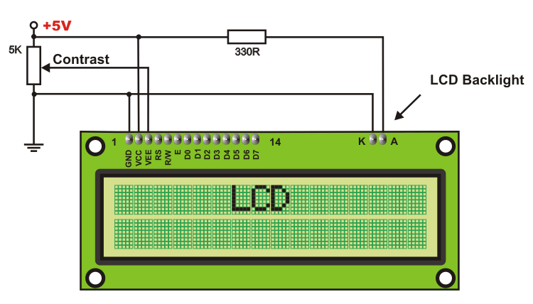

LCD Basic Commands

All data transferred to LCD through outputs D0-D7 will be interpreted as commands or as data, which depends on logic state on pin RS:

RS = 1 - Bits D0 - D7 are addresses of characters that should be displayed. Built in processor addresses built in “map of characters” and displays corresponding symbols. Displaying position is determined by DDRAM address. This address is either previously defined or the address of previously transferred character is automatically incremented.

RS = 0 - Bits D0 - D7 are commands which determine display mode.

Depending on how many lines are used for connection to the microcontroller, there are 8-bit and 4-bit LCD modes. The appropriate mode is determined at the beginning of the process in a phase called “initialization”. In the first case, the data are transferred through outputs D0-D7 as it has been already explained. In case of 4-bit LED mode, for the sake of saving valuable I/O pins of the microcontroller, there are only 4 higher bits (D4-D7) used for communication, while other may be left unconnected.

Consequently, each data is sent to LCD in two steps: four higher bits are sent first (that normally would be sent through lines D4-D7), four lower bits are sent afterwards. With the help of initialization, LCD will correctly connect and interpret each data received. Besides, with regards to the fact that data are rarely read from LCD (data mainly are transferred from microcontroller to LCD) one more I/O pin may be saved by simple connecting R/W pin to the Ground. Such saving has its price. Even though message displaying will be normally performed, it will not be possible to read from busy flag since it is not possible to read from display.

LCD Initialization

Once the power supply is turned on, LCD is automatically cleared. This process lasts for approximately 15mS. After that, display is ready to operate. The mode of operating is set by default. This means that:

1. Display is cleared

2. Mode

DL = 1 Communication through 8-bit interface

N = 0 Messages are displayed in one line

F = 0 Character font 5 x 8 dots

3. Display/Cursor on/off

D = 0 Display off

U = 0 Cursor off

B = 0 Cursor blink off

4. Character entry

ID = 1 Addresses on display are automatically incremented by 1

S = 0 Display shift off

Automatic reset is mainly performed without any problems. Mainly but not always! If for any reason power supply voltage does not reach full value in the course of 10mS, display will start perform completely unpredictably. If voltage supply unit can not meet this condition or if it is needed to provide completely safe operating, the process of initialization by which a new reset enabling display to operate normally must be applied.

3.2.9 SERIAL COMMUNICATION

The main requirements for serial communication are:

1. Microcontroller

2. PC

3. RS 232 cable

4. MAX 232 IC

5. HyperTerminal

When the pins P3.0 and P3.1 of microcontroller are set, UART which is inbuilt in the microcontroller will be enabled to start the serial communication.

TIMERS:

The 8051 has two timers: Timer 0 and Timer 1. They can be used either as timers to generate a time delay or as counters to count events happening outside the microcontroller.

Both Timer 0 and Timer 1 are 16-bit wide. Since the 8051 has an 8-bit architecture, each 16-bit timer is accessed as two separate registers of low byte and high byte.

Lower byte register of Timer 0 is TL0 and higher byte is TH0. Similarly lower byte register of Timer1 is TL1 and higher byte register is TH1.

TMOD (timer mode) register:

Both timers 0 and 1 use the same register TMOD to set the various operation modes.

TMOD is an 8-bit register in which the lower 4 bits are set aside for Timer 0 and the upper 4 bits for Timer 1. In each case, the lower 2 bits are used to set the timer mode and the upper 2 bits to specify the operation.

(MSB) (LSB)

GATE C/T M1 M0 GATE C/T M1 M0

TIMER 1 TIMER 0

GATE

Every timer has a means of starting and stopping. Some timers do this by software, some

by hardware and some have both software and hardware controls. The timers in the 8051 have both. The start and stop of the timer are controlled by the way of software by the TR (timer start) bits TR0 and TR1. These instructions start and stop the timers as long as GATE=0 in the TMOD register. The hardware way of starting and stopping the timer by an external source is achieved by making GATE=1 in the TMOD register.

C/T:Timer or counter selected. Cleared for timer operation and set for counter operation.

M1 Mode bit 1

M0 Mode bit 0

M1 M0 Mode Operating Mode

0 0 0 13-bit timer mode

8-bit timer/counter THx with TLx as 5-bit prescaler

0 1 1 16-bit timer mode

16-bit timer/counters THx and TLx are cascaded

1 0 2 8-bit auto reload timer/counter

THx holds a value that is to be reloaded into TLx each time

it overflows

1 1 3 Split timer mode

The mode used here to generate a time delay is MODE 2.

This mode 2 is an 8-bit timer and therefore it allows only values of 00H to FFH to be loaded into the timer’s register TH. After TH is loaded with the 8-bit value, the 8051 give a copy of it to TL. When the timer starts, it starts to count up by incrementing the TL register. It counts up until it reaches its limit of FFH. When it rolls over from FFH to 00H, it sets high the TF (timer flag). If Timer 0 is used, TF0 goes high and if Timer 1 is used, TF1 goes high. When the TL register rolls from FFH to 0 and TF is set to 1, TL is reloaded automatically with the original value kept by the TH register.

Asynchronous and Synchronous Communication

Computers transfer data in two ways: parallel and serial. In parallel data transfers, often 8 or more lines are used to transfer data to a device that is only a few feet away. Although a lot of data can be transferred in a short amount of time by using many wires in parallel, the distance cannot be great. To transfer to a device located many meters away, the serial method is best suitable.

In serial communication, the data is sent one bit at a time. The 8051 has serial communication capability built into it, thereby making possible fast data transfer using only a few wires.

The fact that serial communication uses a single data line instead of the 8-bit data line instead of the 8-bit data line of parallel communication not only makes it cheaper but also enables two computers located in two different cities to communicate over the telephone.

Serial data communication uses two methods, asynchronous and synchronous. The synchronous method transfers a block of data at a time, while the asynchronous method transfers a single byte at a time. With synchronous communications, the two devices initially synchronize themselves to each other, and then continually send characters to stay in sync. Even when data is not really being sent, a constant flow of bits allows each device to know where the other is at any given time. That is, each character that is sent is either actual data or an idle character. Synchronous communications allows faster data transfer rates than asynchronous methods, because additional bits to mark the beginning and end of each data byte are not required. The serial ports on IBM-style PCs are asynchronous devices and therefore only support asynchronous serial communications.

Asynchronous means "no synchronization", and thus does not require sending and receiving idle characters. However, the beginning and end of each byte of data must be identified by start and stop bits. The start bit indicates when the data byte is about to begin and the stop bit signals when it ends. The requirement to send these additional two bits causes asynchronous communication to be slightly slower than synchronous however it has the advantage that the processor does not have to deal with the additional idle characters.

There are special IC chips made by many manufacturers for serial data communications. These chips are commonly referred to as UART(universal asynchronous receiver-transmitter) and USART(universal synchronous-asynchronous receiver-transmitter). The 8051 has a built-in UART.

The rate of data transfer in serial data communication is stated as bps (bits per second). Another widely used terminology for bps is baud rate. The data transfer rate of a given computer system depends on communication ports incorporated into that system. And in asynchronous serial data communication, this baud rate is generally limited to 100,000bps. The baud rate is fixed to 9600bps in order to interface with the microcontroller using a crystal of 11.0592 MHz.

RS232 CABLE:

To allow compatibility among data communication equipment, an interfacing standard called RS232 is used. Since the standard was set long before the advent of the TTL logic family, its input and output voltage levels are not TTL compatible. For this reason, to connect any RS232 to a microcontroller system, voltage converters such as MAX232 are used to convert the TTL logic levels to the RS232 voltage levels and vice versa.

MAX 232:

Max232 IC is a specialized circuit which makes standard voltages as required by RS232 standards. This IC provides best noise rejection and very reliable against discharges and short circuits. MAX232 IC chips are commonly referred to as line drivers.

To ensure data transfer between PC and microcontroller, the baud rate and voltage levels of Microcontroller and PC should be the same. The voltage levels of microcontroller are logic1 and logic 0 i.e., logic 1 is +5V and logic 0 is 0V. But for PC, RS232 voltage levels are considered and they are: logic 1 is taken as -3V to -25V and logic 0 as +3V to +25V. So, in order to equal these voltage levels, MAX232 IC is used. Thus this IC converts RS232 voltage levels to microcontroller voltage levels and vice versa.
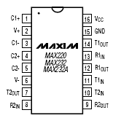

Fig12: Pin diagram of MAX 232 IC

3.2.10 SCON (serial control) register:

The SCON register is an 8-bit register used to program the start bit, stop bit and data bits of data framing.

SM0 SM1 SM2 REN TB8 RB8 TI RI

SM0 SCON.7 Serial port mode specifier

SM1 SCON.6 Serial port mode specifier

SM2 SCON.5 Used for multiprocessor communication

REN SCON.4 Set/cleared by software to enable/disable reception

TB8 SCON.3 Not widely used

RB8 SCON.2 Not widely used

TI SCON.1 Transmit interrupt flag. Set by hardware at the

beginning of the stop bit in mode 1must be cleared

RI SCON.0 Receive interrupt flag. Set by hardware at the

beginning of the stop bit in mode 1. Must be cleared by software.

SM0 SM1

0 0 Serial Mode 0

0 1 Serial Mode 1, 8-bit data, 1 stop bit, 1 start bit

1 0 Serial Mode 2

1 1 Serial Mode 3

Of the four serial modes, only mode 1 is widely used. In the SCON register, when serial mode 1 is chosen, the data framing is 8 bits, 1 stop bit and 1 start bit, which makes it compatible with the COM port of IBM/ compatible PC’s. And the most important is serial mode 1 allows the baud rate to be variable and is set by Timer 1 of the 8051. In serial mode 1, for each character a total of 10 bits are transferred, where the first bit is the start bit, followed by 8 bits of data and finally 1 stop bit.

3.3 POWER SUPPLY

The input to the circuit is applied from the regulated power supply. The a.c. input i.e., 230V from the mains supply is step down by the transformer to 12V and is fed to a rectifier. The output obtained from the rectifier is a pulsating d.c voltage. So in order to get a pure d.c voltage, the output voltage from the rectifier is fed to a filter to remove any a.c components present even after rectification. Now, this voltage is given to a voltage regulator to obtain a pure constant dc voltage.

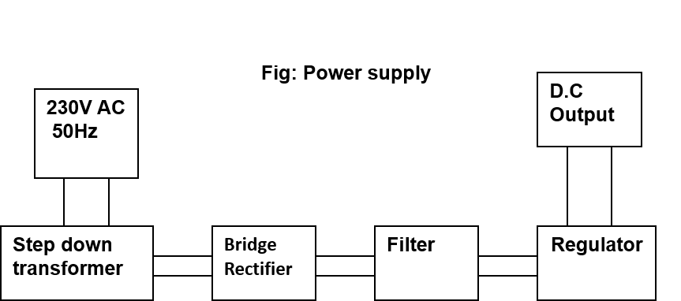

Fig13. Block diagram of power supply units

Transformer:

Usually, DC voltages are required to operate various electronic equipment and these voltages are 5V, 9V or 12V. But these voltages cannot be obtained directly. Thus the a.c input available at the mains supply i.e., 230V is to be brought down to the required voltage level. This is done by a transformer. Thus, a step down transformer is employed to decrease the voltage to a required level.

Rectifier:

The output from the transformer is fed to the rectifier. It converts A.C. into pulsating D.C. The rectifier may be a half wave or a full wave rectifier. In this project, a bridge rectifier is used because of its merits like good stability and full wave rectification.

Filter:

Capacitive filter is used in this project. It removes the ripples from the output of rectifier and smoothens the D.C. Output received from this filter is constant until the mains voltage and load is maintained constant. However, if either of the two is varied, D.C. voltage received at this point changes. Therefore a regulator is applied at the output stage.

Voltage regulator:

As the name itself implies, it regulates the input applied to it. A voltage regulator is an electrical regulator designed to automatically maintain a constant voltage level. In this project, power supply of 5V and 12V are required. In order to obtain these voltage levels, 7805 and 7812 voltage regulators are to be used. The first number 78 represents positive supply and the numbers 05, 12 represent the required output voltage levels.

Proload:

Proload is a software which accepts only hex files. Once the machine code is converted into hex code, that hex code has to be dumped into the microcontroller and this is done by the Proload. Proload is a programmer which itself contains a microcontroller in it other than the one which is to be programmed. This microcontroller has a program in it written in such a way that it accepts the hex file from the keil compiler and dumps this hex file into the microcontroller which is to be programmed. As the proload programmer kit requires power supply to be operated, this power supply is given from the power supply circuit designed above. It should be noted that this programmer kit contains a power supply section in the board itself but in order to switch on that power supply, a source is required. Thus this is accomplished from the power supply board with an output of 12volts.

3.4 DC MOTOR AND H-BRIDGE

THEORY OF DC MOTOR

The speed of a DC motor is directly proportional to the supply voltage, so if we reduce the supply voltage from 12 Volts to 6 Volts, the motor will run at half the speed. How can this be achieved when the battery is fixed at 12 Volts? The speed controller works by varying the average voltage sent to the motor. It could do this by simply adjusting the voltage sent to the motor, but this is quite inefficient to do. A better way is to switch the motor's supply on and off very quickly. If the switching is fast enough, the motor doesn't notice it, it only notices the average effect.

When you watch a film in the cinema, or the television, what you are actually seeing is a series of fixed pictures, which change rapidly enough that your eyes just see the average effect - movement. Your brain fills in the gaps to give an average effect.

Now imagine a light bulb with a switch. When you close the switch, the bulb goes on and is at full brightness, say 100 Watts. When you open the switch it goes off (0 Watts). Now if you close the switch for a fraction of a second, then open it for the same amount of time, the filament won't have time to cool down and heat up, and you will just get an average glow of 50 Watts. This is how lamp dimmers work, and the same principle is used by speed controllers to drive a motor. When the switch is closed, the motor sees 12 Volts, and when it is open it sees 0 Volts. If the switch is open for the same amount of time as it is closed, the motor will see an average of 6 Volts, and will run more slowly accordingly. The graph below shows the speed of a motor that is being turned on and off

Principles of operation

In any electric motor, operation is based on simple electromagnetism. A current-carrying conductor generates a magnetic field; when this is then placed in an external magnetic field, it will experience a force proportional to the current in the conductor, and to the strength of the external magnetic field. As you are well aware of from playing with magnets as a kid, opposite (North and South) polarities attract, while like polarities (North and North, South and South) repel. The internal configuration of a DC motor is designed to harness the magnetic interaction between a current-carrying conductor and an external magnetic field to generate rotational motion.

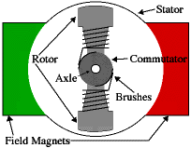
Let's start by looking at a simple 2-pole DC electric motor (here red represents a magnet or winding with a "North" polarization, while green represents a magnet or winding with a "South" polarization).

Every DC motor has six basic parts -- axle, rotor (a.k.a., armature), stator, commutator, field magnet(s), and brushes. In most common DC motors (and all that BEAMers will see), the external magnetic field is produced by high-strength permanent magnets1. The stator is the stationary part of the motor -- this includes the motor casing, as well as two or more permanent magnet pole pieces. The rotor (together with the axle and attached commutator) rotate with respect to the stator. The rotor consists of windings (generally on a core), the windings being electrically connected to the commutator. The above diagram shows a common motor layout -- with the rotor inside the stator (field) magnets.

The geometry of the brushes, commutator contacts, and rotor windings are such that when power is applied, the polarities of the energized winding and the stator magnet(s) are misaligned, and the rotor will rotate until it is almost aligned with the stator's field magnets. As the rotor reaches alignment, the brushes move to the next commutator contacts, and energize the next winding. Given our example two-pole motor, the rotation reverses the direction of current through the rotor winding, leading to a "flip" of the rotor's magnetic field, driving it to continue rotating.

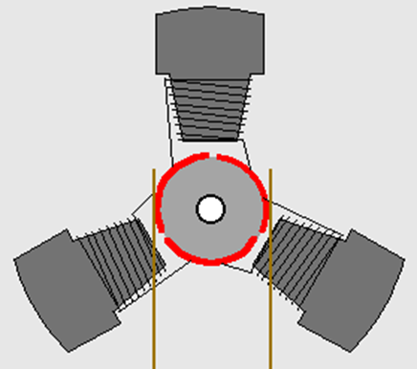

In real life, though, DC motors will always have more than two poles (three is a very common number). In particular, this avoids "dead spots" in the commutator. You can imagine how with our example two-pole motor, if the rotor is exactly at the middle of its rotation (perfectly aligned with the field magnets), it will get "stuck" there. Meanwhile, with a two-pole motor, there is a moment where the commutator shorts out the power supply (i.e., both brushes touch both commutator contacts simultaneously). This would be bad for the power supply, waste energy, and damage motor components as well. Yet another disadvantage of such a simple motor is that it would exhibit a high amount of torque "ripple" (the amount of torque it could produce is cyclic with the position of the rotor).

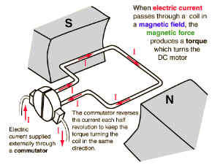 | 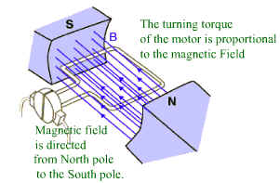
Figure 13.1: Force in DC Motor | Figure 13.2 : Magnetic Field in DC Motor

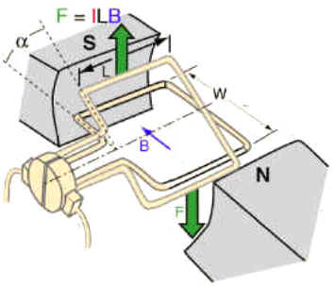
Figure 13.3 : Torque in DC Motor | Figure 13.4 : Current Flow in DC Motor

Fig14.Stages of DC Motor

If an Electric current flows through two copper wires that are between the poles of a magnet, an upward force will move one wire up and a downward force will move the other wire down. The loop can be made to spin by fixing a half circle of copper which is known as COMMUTATOR to each end of the loop. Current is passed into and out of the loop by brushes that press onto the strips. The BRUSHES do not go round so the wire do not get twisted. This arrangement also makes sure that the current always passes down on the right and back on the left so that the rotation continues. This is how a simple Electric motor is made.

3.4.1 H-BRIDGE

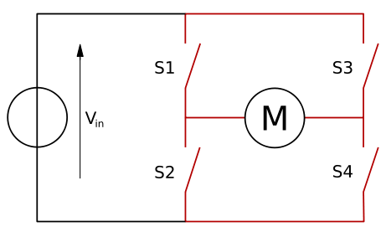
An H-bridge is an electronic circuit which enables DC electric motors to be run forwards or backwards. These circuits are often used in robotics. H-bridges are available as integrated circuits, or can be built from discrete components.

The two basic states of a H-bridge. The term "H-bridge" is derived from the typical graphical representation of such a circuit. An H-bridge is built with four switches (solid-state or mechanical). When the switches S1 and S4 (according to the first figure) are closed (and S2 and S3 are open) a positive voltage will be applied across the motor. By opening S1 and S4 switches and closing S2 and S3 switches, this voltage is reversed, allowing reverse operation of the motor.

Using the nomenclature above, the switches S1 and S2 should never be closed at the same time, as this would cause a short circuit on the input voltage source. The same applies to the switches S3 and S4. This condition is known as shoot-through.

Operation

The H-Bridge arrangement is generally used to reverse the polarity of the motor, but can also be used to 'brake' the motor, where the motor comes to a sudden stop, as the motors terminals are shorted, or to let the motor 'free run' to a stop, as the motor is effectively disconnected from the circuit. The following table summarizes operation.

S1 | S2 | S3 | S4 | Result
1 | 0 | 0 | 1 | Motor moves right
0 | 1 | 1 | 0 | Motor moves left
0 | 0 | 0 | 0 | Motor free runs
0 | 1 | 0 | 1 | Motor brakes

Table4.Motion of motor based on active pins of L293D

H-Bridge Driver

The switching property of this H-Bridge can be replace by a Transistor or a Relay or a Mosfet or even by an IC. Here we are replacing this with an IC named L293D as the driver whose description is as given below.

Features:
- 600mA OUTPUT CURRENT CAPABILITY
- PER CHANNEL
- 1.2A PEAK OUTPUT CURRENT (non repetitive)
- PER CHANNEL
- ENABLE FACILITY
- OVERTEMPERATURE PROTECTION
- LOGICAL "0" INPUT VOLTAGE UP TO 1.5 V
- (HIGH NOISE IMMUNITY)
- INTERNAL CLAMP DIODES

DESCRIPTION

The Device is a monolithic integrated high voltage, high current four channel driver designed to accept standard DTL or TTL logic levels and drive inductive loads (such as relays solenoides, DC and stepping motors) and switching power transistors. To simplify use as two bridges each pair of channels is equipped with an enable input. A separate supply input is provided for the logic, allowing operation at a lower voltage and internal clamp diodes are included. This device is suitable for use in switching applications at frequencies up to 5 kHz. The L293D is assembled in a 16 lead plastic packaage which has 4 center pins connected together and used for heatsinking The L293DD is assembled in a 20 lead surface mount which has 8 center pins connected together and used for heatsinking.

BLOCK DIAGRAM:

Fig15.Block diagram of H bridge driver

ABSOLUTE MAXIMUM RATINGS

Table4.Rated parameters of H bridge driver circuit

PIN CONNECTIONS

RELAYS:

A relay is an electrically controllable switch widely used in industrial controls, automobiles and appliances.

The relay allows the isolation of two separate sections of a system with two different voltage sources i.e., a small amount of voltage/current on one side can handle a large amount of voltage/current on the other side but there is no chance that these two voltages mix up.

Inductor

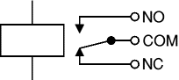

Fig16: Circuit symbol of a relay

Operation:

When a current flow through the coil, a magnetic field is created around the coil i.e., the coil is energized. This causes the armature to be attracted to the coil. The armature’s contact acts like a switch and closes or opens the circuit. When the coil is not energized, a spring pulls the armature to its normal state of open or closed. There are all types of relays for all kinds of applications.

0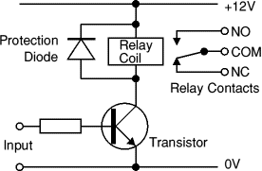

Fig17: Relay Operation and use of protection diodes

Transistors and ICs must be protected from the brief high voltage 'spike' produced when the relay coil is switched off. The above diagram shows how a signal diode (eg 1N4148) is connected across the relay coil to provide this protection. The diode is connected 'backwards' so that it will normally not conduct. Conduction occurs only when the relay coil is switched off, at this moment the current tries to flow continuously through the coil and it is safely diverted through the diode. Without the diode no current could flow and the coil would produce a damaging high voltage 'spike' in its attempt to keep the current flowing.

In choosing a relay, the following characteristics need to be considered:

1. The contacts can be normally open (NO) or normally closed (NC). In the NC type, the contacts are closed when the coil is not energized. In the NO type, the contacts are closed when the coil is energized.

2. There can be one or more contacts. i.e., different types like SPST (single pole single throw), SPDT (single pole double throw) and DPDT (double pole double throw) relays.

3. The voltage and current required to energize the coil. The voltage can vary from a few volts to 50 volts, while the current can be from a few milliamps to 20milliamps. The relay has a minimum voltage, below which the coil will not be energized. This minimum voltage is called the “pull-in” voltage.

4. The minimum DC/AC voltage and current that can be handled by the contacts. This is in the range of a few volts to hundreds of volts, while the current can be from a few amps to 40A or more, depending on the relay.

TRANSISTOR DRIVER CIRCUIT:

An SPDT relay consists of five pins, two for the magnetic coil, one as the common terminal and the last pins as normally connected pin and normally closed pin. When the current flows through this coil, the coil gets energized. Initially when the coil is not energized, there will be a connection between the common terminal and normally closed pin. But when the coil is energized, this connection breaks and a new connection between the common terminal and normally open pin will be established. Thus when there is an input from the microcontroller to the relay, the relay will be switched on. Thus when the relay is on, it can drive the loads connected between the common terminal and normally open pin. Therefore, the relay takes 5V from the microcontroller and drives the loads which consume high currents. Thus the relay acts as an isolation device. Digital systems and microcontroller pins lack sufficient current to drive the relay. While the relay’s coil needs around 10milli amps to be energized, the microcontroller’s pin can provide a maximum of 1-2milli amps current. For this reason, a driver such as a power transistor is placed in between the microcontroller and the relay.

AT89C51

P1.0
Vcc

RELAY
GROUND

The operation of this circuit is as follows:

The input to the base of the transistor is applied from the microcontroller port pin P1.0. The transistor will be switched on when the base to emitter voltage is greater than 0.7V (cut-in voltage). Thus when the voltage applied to the pin P1.0 is high i.e., P1.0=1 (>0.7V), the transistor will be switched on and thus the relay will be ON and the load will be operated.

When the voltage at the pin P1.0 is low i.e., P1.0=0 (<0.7V) the transistor will be in off state and the relay will be OFF. Thus the transistor acts like a current driver to operate the relay accordingly.

Relay Interfacing with Microcontroller:

AT 89S52

P1.0

DRIVER
CIRCUIT

RELAY
LOAD

4.RESULT
4.1 Output Result:
The smart airport luggage system proposed in this project was fully developed and tested to demonstrate its feasibility and effectiveness. The implementation of realization of “RFID Based Airport Luggage Security scanning system” is done successfully. The communication is properly done without any interference between different modules in the design. Design is done to meet all the specifications and requirements. Software tools like keil micro vision simulator, proload to dump the source code into the microcontroller have been used to develop the software code before realizing the hardware. Circuit is implemented on the microcontroller board. The performance has been verified both in software simulator and hardware design. The total circuit is completely verified functionally and is following the application software. It can be concluded that the design implemented in the present work provide portability, flexibility and the data transmission is also done with low power consumption.

4.2 PROGRAMMING CODE:

#include<reg52.h>

#include<intrins.h>

#include<string.h>

#define ldata P1

sbit rs=P1^4;

sbit rw=P1^5;

sbit en=P1^6;

sbit enroll=P2^0;

sbit update=P2^1;

void command(unsigned char);

void lcddata(unsigned char);

void serialinit(void);

void start(void);

void write(unsigned char ,unsigned char);

unsigned char read(unsigned char);

void ptos(unsigned char );

void stop(void);

void delay(unsigned char);

void lcdintl(void);

void message(unsigned char,unsigned char *);

void conv(unsigned char x);

void send_com(unsigned char );

void send_arr(unsigned char *);

void cont_write(void);

void serialstore(void);

unsigned char compare(unsigned char *,unsigned char *);

void delay1(unsigned int);

unsigned char cmd[] = {0x38,0x0E,0x01,0x06,0x83,0};

unsigned char a=1,i,j,loc=0,check=0,ch,badd=0,count,buffer[14];

unsigned char id_read1[10],id_read2[10],id_read3[10],id_read4[10],id_read5[10],id[10];

void main(void)

{ unsigned char i;

lcdintl();

if(enroll==0)

{ message(0X80," PLACE THE CARD ");

message(0XC0," TO ENROLL ");

serialinit();

while(1)

{ if(ch>=10)

{ command(0X01);

message(0X80,"ENROLLING.... ");

delay(100);

cont_write();

message(0X80," PLACE THE CARD ");

message(0XC0," TO ENROLL ");

}}//while

}//if while(1)

{ start:

message(0X80," PLACE THE CARD ");

delay(50);

serialinit();

delay(50);

serialstore();

a=compare(id,id_read1);

if(a==0)

{ message(0X80," AUTHORISED ");

delay(200);

delay(100);

goto start; }

a=compare(id,id_read2);

if(a==0)

{ message(0X80," AUTHORISED ");

delay(200);

delay(100);

goto start; }

a=compare(id,id_read3);

if(a==0)

{ message(0X80," AUTHORISED ");

delay(200);

delay(100);

goto start;

} } }

///////////////////////////////////////////////////////////////////////////////////////////////////////////////////////////////////////

void send_com(unsigned char arr_ch)

{ SBUF=arr_ch;

while(TI==0);

TI=0; }

///////////////////////////////////////////////////////////////////////////////////////////////////////////////////////////////////////

void send_arr(unsigned char *arr)

{ unsigned int i=0;

while(arr[i]!='\0')

{ SBUF=arr[i++];

while(TI==0);

TI=0; }

send_com(0X0D); }

///////////////////////////////////////////////////////////////////////////////////////////////////////////////////////////////////////

void serialinit(void)

{ TMOD = 0X20;

TH1 = 0XFD;

SCON = 0X50;

TR1 = 1; }

///////////////////////////////////////////////////////////////////////////////////////////////////////////////////////////////////////

void serialstore(void)

{ unsigned char n=0;

while(n<=9)

{ while(RI==0);

id[n]= SBUF;

n++; } }

///////////////////////////////////////////////////////////////////////////////////////////////////////////////////////////////////////

unsigned char compare(unsigned char *kk,unsigned char *hh)

{ unsigned char i=0,j=0,e;

for(e=0;e<=9;e++)

{ if(kk[i]==hh[i])

{ j=1;

return j; }

else

{ i++;

j=0; } }

return j; }

///////////////////////////////////////////////////////////////////////////////////////////////////////////////////////////////////////

void write(unsigned char baddr,unsigned char dat)

{ start();

ptos(0XA0); //device addr in write mode//

ptos(baddr); //byte addr//

ptos(dat); //data//

stop(); }

///////////////////////////////////////////////////////////////////////////////////////////////////////////////////////////////////////

unsigned char read(unsigned char baddr)

{ unsigned char i,v=0;

start();

ptos(0XA0); //device addr in write mode//

ptos(baddr); //byte addr//

_nop_();

start();

ptos(0XA0+1); //device addr in read mode//

SDA=1;

for(i=0;i<=7;i++)

{ SCL=0;

_nop_();

_nop_();

SCL=1;

v=v<<1; }

SCL=0;

stop();

return v; }

////////////////////////////////////////////////////////////////////////////////////////////////////////////////////////////////////

void start(void)

{ SCL=1;

SDA=1;

_nop_();

_nop_();

SDA=0;

SCL=0; }

////////////////////////////////////////////////////////////////////////////////////////////////////////////////////////////////////

void ptos(unsigned char a)

{ unsigned char i,c;

for(i=0;i<=7;i++)

{ c=a&128;

if(c==0)

SDA=0;

Else

SDA=1;

a=a<<1; }

SDA=1;

_nop_();

_nop_();

SCL=1;

_nop_();

_nop_();

SCL=0; }

///////////////////////////////////////////////////////////////////////////////////////////////////////////////////////////////////////

void stop(void)

{ SDA=0;

SCL=1;

_nop_();

_nop_();

SDA=1;

SCL=0; }

///////////////////////////////////////////////////////////////////////////////////////////////////////////////////////////////////////

void delay(unsigned char s)

{ unsigned char i,j;

for(i=0;i<=s;i++)

{ for(j=0;j<=250;j++); }}

///////////////////////////////////////////////////////////////////////////////////////////////////////////////////////////////////////

void cont_write(void)

{ loc=read(0);

for(count=loc,i=0;i<=9;count++,i++)

{ write(count,buffer[i]); }

write(0,count);

ch=0; }

///////////////////////////////////////////////////////////////////////////////////////////////////////////////////////////////////////

void lcdintl(void)

{ unsigned char i;

for(i=0;cmd[i]==0;i++)

{ command(cmd[i]); } }

///////////////////////////////////////////////////////////////////////////////////////////////////////////////////////////////////////

void command(unsigned char value)

{ ldata = value;

rs = 0;

rw = 0;

en = 1;

delay(5);

en = 0; }

///////////////////////////////////////////////////////////////////////////////////////////////////////////////////////////////////////

void lcddata(unsigned char value)

{ ldata = value;

rs = 1;

rw = 0;

en = 1;

delay(5);

en = 0; }

////////////////////////////////////////////////////////////////////////////////////////////////////////////////////////////////////////

void message(unsigned char value,unsigned char d)

{ unsigned char i;

command(value);

for(i=0;d[i]!=0;i++)

{ lcddata(d[i]);

delay(15); }}

////////////////////////////////////////////////////////////////////////////////////////////////////////////////////////////////////////////

void delay1(unsigned int g)

{ unsigned int j,k;

for(j=0;j<1275;j++)

for(k=0;k<g;k++); }

5. CONCLUSION

In this project work, we have studied and implemented a complete working model using a Microcontroller. The programming and interfacing of microcontroller has been mastered during the implementation. This work includes the study of RFID module.

RFID is increasingly used with biometric technologies for security. The significant advantage of all types of RFID systems is the non-contact, non-line-of-sight nature of the technology. Tags can be read through a variety of substances such as snow, fog, ice, paint. Hence, this project can be very much useful and can be implemented in real time applications for recording the attendance.

5.1 Future Scope
- A Front Camera can be used for Lane Tracking purpose. This will really helpful for an advanced security for luggages.
- System can be monitored & globally tracking using PC. Presently PCs have been under work so developing the system in this scenario is economical too.
- Instead of a Microcontroller we can use a CPLD chip since the CPLD incorporates many more features than a Microcontroller. VLSI/VHDL can be used for CPLD programming. This may make the system expensive , but the accuracy of the system will be hundred percent.

REFERENCES:

1. WWW. howstuffworks.com

2. EMBEDDED SYSTEM BY RAJ KAMAL

3. 8051 MICROCONTROLLER AND EMBEDDED SYSTEMS BY MAZZIDI

4. Magazines

5. Electronics for you

6. Electrikindia

7. www.google.com

8. www.Electronicprojects.com

